**Nang Thiri Wutyi**

**20113**

**10/9/2024**

**Verilog Lab #3 Combinational Logic**

1. **XOR3 Circuit**

`timescale 1ns/100ps

module xor3 (input a_i, b_i, c_i, output y_o);

wire aBar_w, bBar_w, cBar_w;

wire im1_w, im2_w, im3_w, im4_w;

not (aBar_w, a_i),

(bBar_w, b_i),

(cBar_w, c_i);

nand (im1_w, aBar_w, bBar_w, c_i),

(im2_w, aBar_w, b_i, cBar_w),

(im3_w, aBar_w, bBar_w, cBar_w),

(im4_w, a_i, b_i, c_i);

nand (y_o, im1_w, im2_w, im3_w, im4_w);

endmodule

**Majority Circuit**

`timescale 1ns/100ps

module maj3(input a_i, b_i, c_i, output y_o);

wire im1_w, im2_w, im3_w;

and (im1_w, a_i, b_i),

(im2_w, b_i, c_i),

(im3_w, c_i, a_i);

or (y_o, im1_w, im2_w, im3_w);

endmodule

**Combining XOR3 and Majority into a 1-bit Full Adder**

`include "maj3.v"

`include "xor3.v"

`timescale 1ns/100ps

module AddOneBitP (input a_i, b_i, ci_i, output sum_o, co_o);

xor3 Uxor3 (.a_i(a_i), .b_i(b_i), .c_i(ci_i), .y_o(sum_o));

maj3 Umaj3 (.a_i(a_i), .b_i(b_i), .c_i(ci_i), .y_o(co_o));

endmodule

1. **1-bit Full Adder using assign**

`timescale 1ns/100ps

module add_1bit(input a, b, ci, output s, co);

assign {co, s} = {(a & b) | (b & ci) | (a & ci), a ^ b ^ ci};

endmodule

**2-to-4 Decoder using Conditional Assignment**

`timescale 1ns/100ps

module dcd2_4(input a, b, output d0, d1, d2, d3);

assign {d3, d2, d1, d0} = ( {a, b} == 2'b00 ) ? 4'b0001 :

( {a, b} == 2'b01 ) ? 4'b0010 :

( {a, b} == 2'b10 ) ? 4'b0100 :

( {a, b} == 2'b11 ) ? 4'b1000 : 4'b0000;

endmodule

**Majority Logic using always Block**

`timescale 1ns/100ps

module maj3(input a, b, c, output reg y);

always @(a, b, c) begin

y = (a & b) | (b & c) | (a & c);

end

endmodule

1. **Majority Logic using always Block**

`timescale 1ns/100ps

module maj3(input a, b, c, output reg y);

always @(a, b, c) begin

y = (a & b) | (b & c) | (a & c);

end

endmodule

1. **Comparison of Mux Implementations**

**4.1 MUX using if-else (IfMux8)**

module IfMux8 (output reg y, input [7:0] i, input [2:0] sel);

always @(i, sel) begin

if (sel == 3'd0) y = i[0];

else if (sel == 3'd1) y = i[1];

else if (sel == 3'd2) y = i[2];

else if (sel == 3'd3) y = i[3];

else if (sel == 3'd4) y = i[4];

else if (sel == 3'd5) y = i[5];

else if (sel == 3'd6) y = i[6];

else if (sel == 3'd7) y = i[7];

end

endmodule

**MUX using case (CaseMux8)**

module CaseMux8 (output reg y, input [7:0] i, input [2:0] sel);

always @(i, sel) begin

case (sel)

3'd0: y = i[0];

3'd1: y = i[1];

3'd2: y = i[2];

3'd3: y = i[3];

3'd4: y = i[4];

3'd5: y = i[5];

3'd6: y = i[6];

3'd7: y = i[7];

endcase

end

endmodule

1. **Race Condition with Multiple Initial Blocks**

module race_condition();

reg b;

initial begin

b = 0;

end

initial begin

b = 1;

end

endmodule

1. **Exercises**
2. **Fix: Missing sensitivity list**

// design.sv

`timescale 1ns/100ps

module my_design(input a, input b, input c, output reg y);

// Using @(*) ensures all relevant inputs are in the sensitivity list.

always @(*) begin

y = (a & b) | (b & c) | (a & c); // Example logic (Majority gate)

end

endmodule

1. **Fix: Conflict between always blocks setting the same variable C**

always@(B or E)

C = |B | ^E;

1. **Fix: Clock enable issue**

always@(posedge clock) begin

if(A)

Q <= D;

end

always@(Q or E) begin

case (Q)

1'b0: F = E;

default: F = 1;

endcase

end

1. **Fix: Wire conflict between two modules**

module top;

wire B;

bar u1 (A, B);

bar u2 (C, B);

endmodule

module bar (input D, output wire E);

assign E = ~D;

endmodule

1. **Fix: Use always block and logic gates together**

module foo(input A,B; output reg E);

wire C,D;

always@(posedge clock) E = B & D;

assign C = A ^ D;

assign D = C | B;

endmodule

**b. According to the IfMux modules**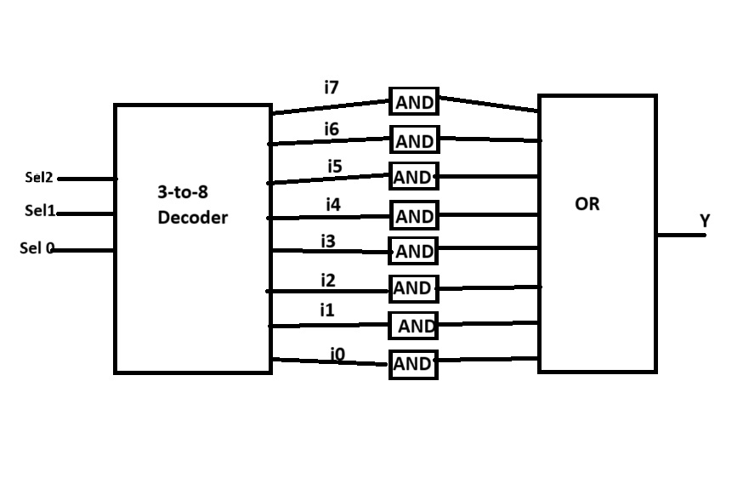

**According to CaseMux8 module**

**Both approaches use a decoder, AND gates, and an OR gate in the same way, so the block diagrams are identical in terms of components and connections.**